**BAK-APP User Manual**

**Index**

1. **Description**
2. **Dependencies**
3. **GUI**
   1. **Finding the Packing Information**
   2. **Adding the Inventory to dataSoure**
   3. **View the Inventory.**
4. **Logs**
5. Description

The BAK-APP application is the GUI and Command Line based small-scale application, which helps the user to find out the packaging information for the given input.

The purpose of this application is to make sure the given input is matched with the minimum number of the packs and to calculate the amount involved for it.

1. Dependencies

This application is based of Java and it requires the JRE environment and junit for test.

1. JDK/JRE 1.8 Version
2. Junit 4.11
3. Log4J 1.2.17
4. GUI

When this application is launched via the script, a GUI opens and show as like the following

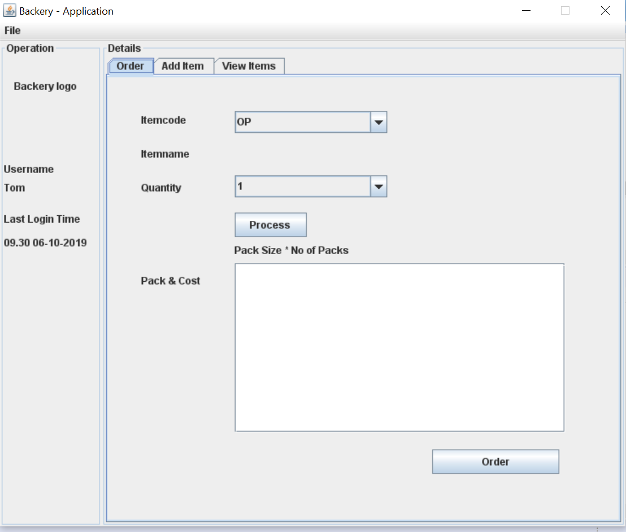

* 1. – Finding the Packaging information

1. Select the ItemCode from the dropdown.
2. Corresponding ItemName gets loaded in the below component.
3. Select the Quantity as per user requirement.
4. Click on the Process button.

The expected output is shown in the textArea.

* 1. - Adding the items to the database

1. On the main tab, user can navigate to Add Items pane.
2. User can add Itemcode, Itemname and the pack information.
3. For now, adding 2 items is enabled.
4. GUI can validate the input given.
5. When a click on the Add , it writes the content to the database(datasource.properties) file.

This is how the Add Item panel look like

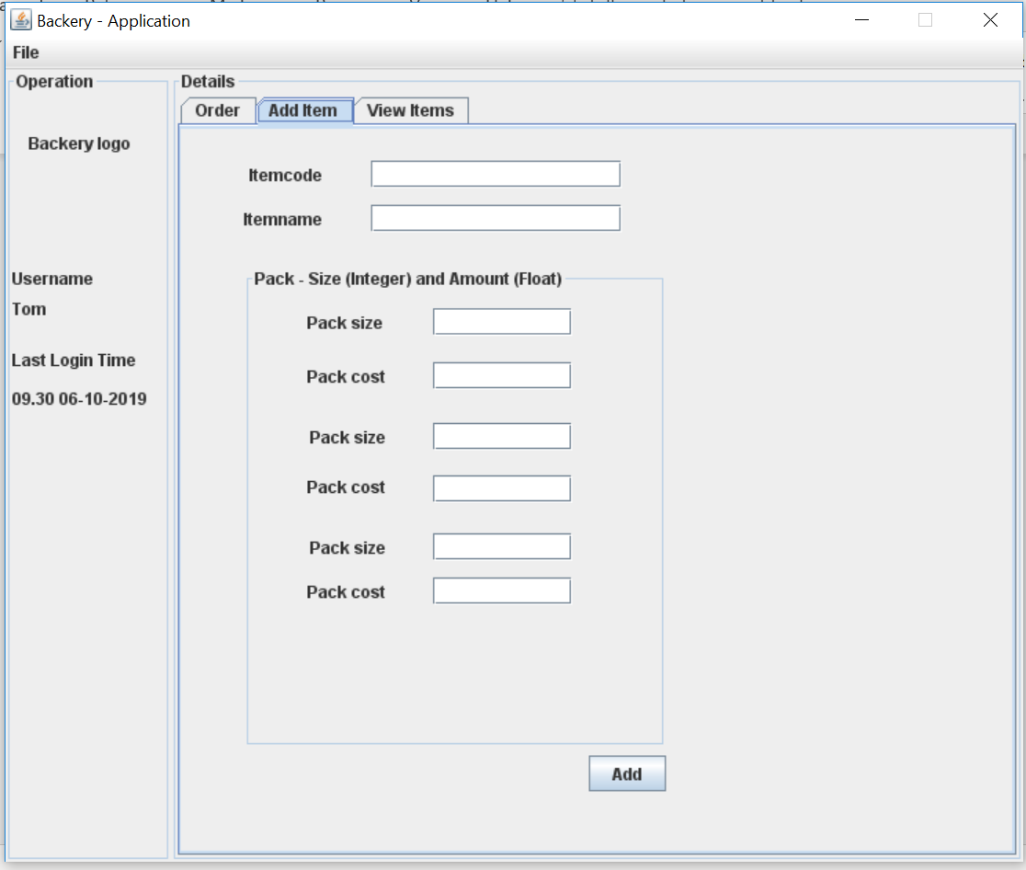

* 1. – View the inventory

1. User can take a look at the existing items available in the inventory.

This is how the inventory panel look like

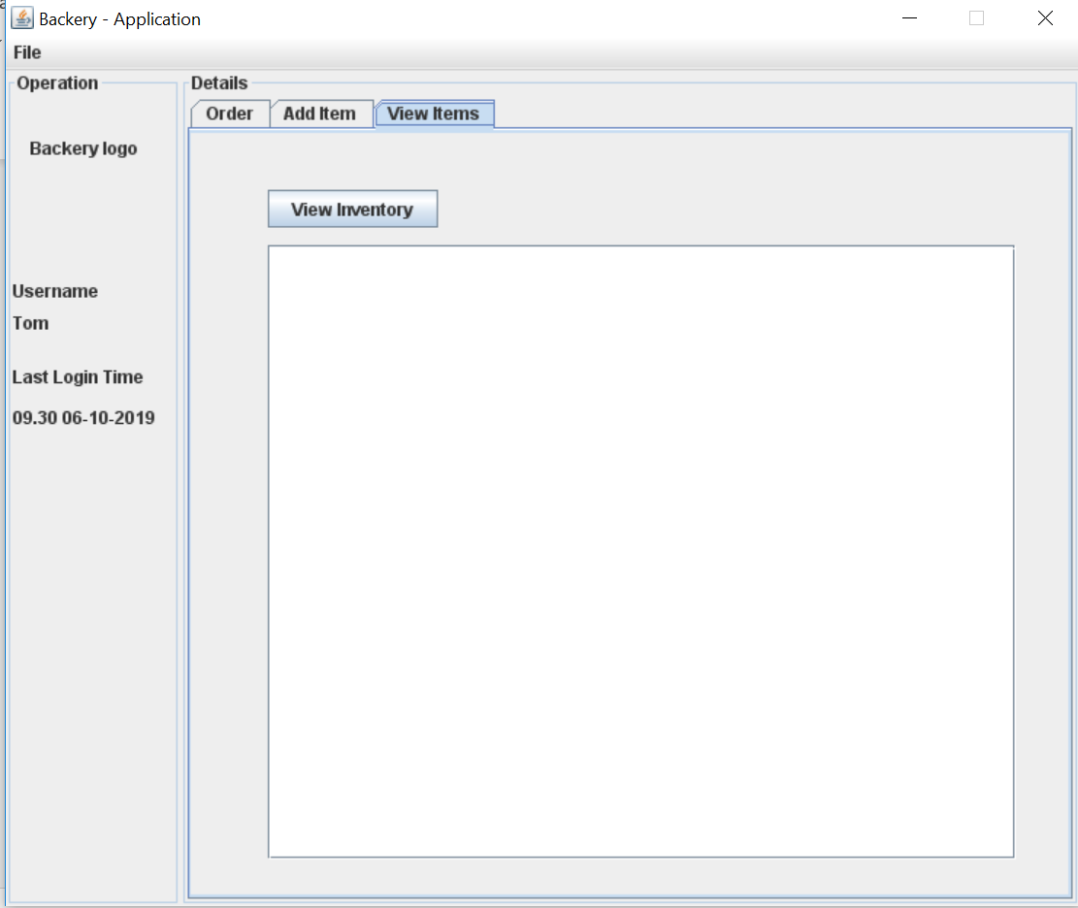

1. Logs

This application writes down the logs on what is happening right from application launch to exit.

User can customize the logs which he/she wants, it can be any of INFO, DEBUG, ERROR and WARN.

The logs gets generated in the C:\ BakeryApplicationlogs\ Directory